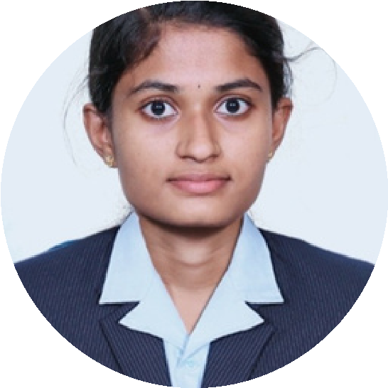

SWETHA S

Student

Language

Reference

•C,C++ and Java certificate from spoken tutorial,IIT Bombay.

•Core Java from Coursera.

•Java explorer badge from Oracle University.

Intership opportunity in web development at codsoft.It is a on

going intership.This helps me to learn more new things in web

development.

• Done a project "SORTING VISUALIZER" based on data

structures and algorithms.

•Created a calculator website with HTML and CSS.

•Created an event management website with HTML.

As a student at Sri Krishna arts and science college,I have an

intermediate level of expertise in several programming

languages like HTML,CSS,JAVA SCRIPT,PHP,C++ and

JAVA.Driven by strong desire to use technology to bring

constructive change.I approach every task with dedication and

innovative ideas.

CERTIFICATES:

linkedin:

INTERNSHIPS:

PROJECTS & WEBSITES:

senthilkumarswetha56@gmail.com

6383538312

1

/1 53 A,padama park,

vijayanagaram

Contact

Education

Skills

Primary schooling:

Higher education:

Madonna matriculation higher

Secondary school.

SVGV Matriculation higher

secondary school.

karamadai.

Karamadai.

Tamil

English

https://www.linkedin.com/in/swetha-senthil-

kumar-509443274?

utm_source=share&utm_campaign=share_via&utm_

content=profile&utm_medium=android_app

HTML

CSS

C++

JAVA SCRIPT

JAVA